**C Practice Problems: Set I-B**

**Part I – Conditionals, loops, nested loops**

**Difficulty level: Medium**

1. [Write a C program to find sum of first and last digit of a number.](http://codeforwin.org/2015/06/c-program-to-find-sum-of-first-and-last-digit-of-number.html)
2. [Write a C program to swap first and last digits of a number](http://codeforwin.org/2016/01/c-program-to-swap-first-and-last-digit-of-number.html).
3. [Write a C program to calculate product of digits of a number](http://codeforwin.org/2015/06/c-program-to-calculate-product-of-digits.html).
4. [Write a C program to enter a number and print its reverse](http://codeforwin.org/2015/06/c-program-to-find-reverse-of-any-number.html).
5. [Write a C program to print all Prime numbers between 1 to n.](http://codeforwin.org/2015/06/c-program-to-print-all-prime-numbers-between-1-to-n.html)
6. [Write a C program to find sum of all prime numbers between 1 to n](http://codeforwin.org/2015/06/c-program-to-find-sum-of-all-prime.html).
7. [Write a C program to find all prime factors of a number](http://codeforwin.org/2015/06/c-program-to-find-all-prime-factors-of-any-number.html).
8. [Write a C program to find two's complement of a binary number](http://codeforwin.org/2015/08/c-program-to-find-twos-complement-of-binary-number.html).
9. [Write a C program to convert Binary to Octal number system](http://codeforwin.org/2015/08/c-program-to-convert-binary-to-octal-number-system.html).
10. [Write a C program to convert Binary to Decimal number system](http://codeforwin.org/2015/08/c-program-to-convert-binary-to-decimal-number-system.html).
11. [Write a C program to print the patterns.](http://codeforwin.org/2015/07/star-patterns-program-in-c.html)

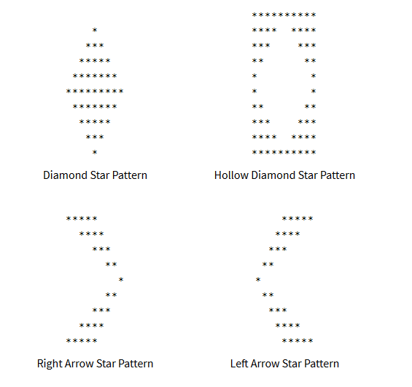

[1](http://codeforwin.org/2016/10/number-pattern-43-in-c.html)

[2  4](http://codeforwin.org/2016/10/number-pattern-43-in-c.html)

[7  11 16](http://codeforwin.org/2016/10/number-pattern-43-in-c.html)

[22 29 37 46](http://codeforwin.org/2016/10/number-pattern-43-in-c.html)

[56 67 79 92 106](http://codeforwin.org/2016/10/number-pattern-43-in-c.html)

[Number pattern 50](http://codeforwin.org/2016/10/number-pattern-43-in-c.html)

[1](http://codeforwin.org/2016/10/number-pattern-44-in-c.html)

[3  2](http://codeforwin.org/2016/10/number-pattern-44-in-c.html)

[4  5  6](http://codeforwin.org/2016/10/number-pattern-44-in-c.html)

[10 9  8  7](http://codeforwin.org/2016/10/number-pattern-44-in-c.html)

[11 12 13 14 15](http://codeforwin.org/2016/10/number-pattern-44-in-c.html)

1

1 2 1

1 2 3 2 1

1 2 3 4 3 2 1

1 2 3 4 5 4 3 2 1

1 2 3 4 3 2 1

1 2 3 2 1

1 2 1

1